Windmill Farm, Otley Road
Planning layout – from www.johnsonmowat.co.uk/windmillfarm
Labelling added by HAPARA based on information from Johnson Mowat.
780 dwellings shown - not including self-build and further development land (total 1000 approx)

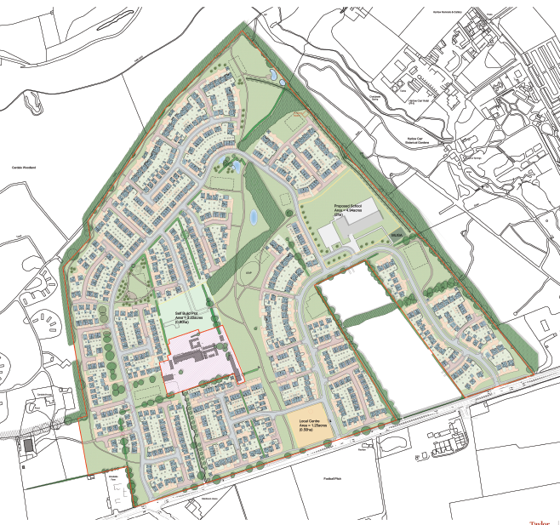
Otley Road
Existing farmhouse (and business?) retained
Area for self-build 40-50 plots
Further development 100 – 200 dwellings
Local store/facilities
RHS Harlow Carr
Primary School

