Bluecoat Park, Otley Road
Persimmon development (125 homes)
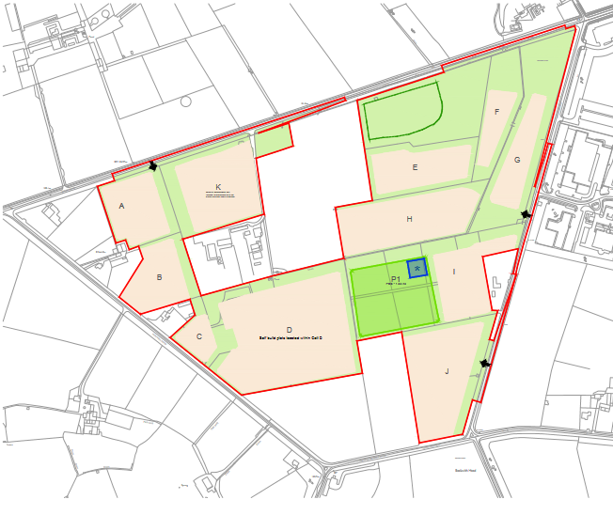
Lady Lane
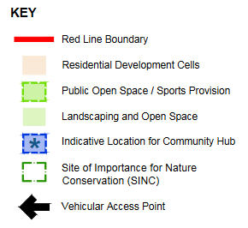
Potential Development Cell (Subject to discussions with the
cricket club and Sports England)
Horticap
Self build plots located within Cell D
Otley Road
Main Land Uses
The proposed development comprises the following:
1 Up to 560 homes of a variety of tenure and size;
2 Community facilities;
3 Sports facilities;
4 Open space;
5 SuDS, including retention basins;
6 A comprehensive landscaping strategy which will provide biodiversity enhancements; and
7 Roads, pedestrian and cycle facilities and associated works
Extracts from Environmental Impact Assessment Scoping Report, Homes England, April 2021
Plan: Appendix 2 (Parameter Plans)
Text box (right): paragraph 4.4

